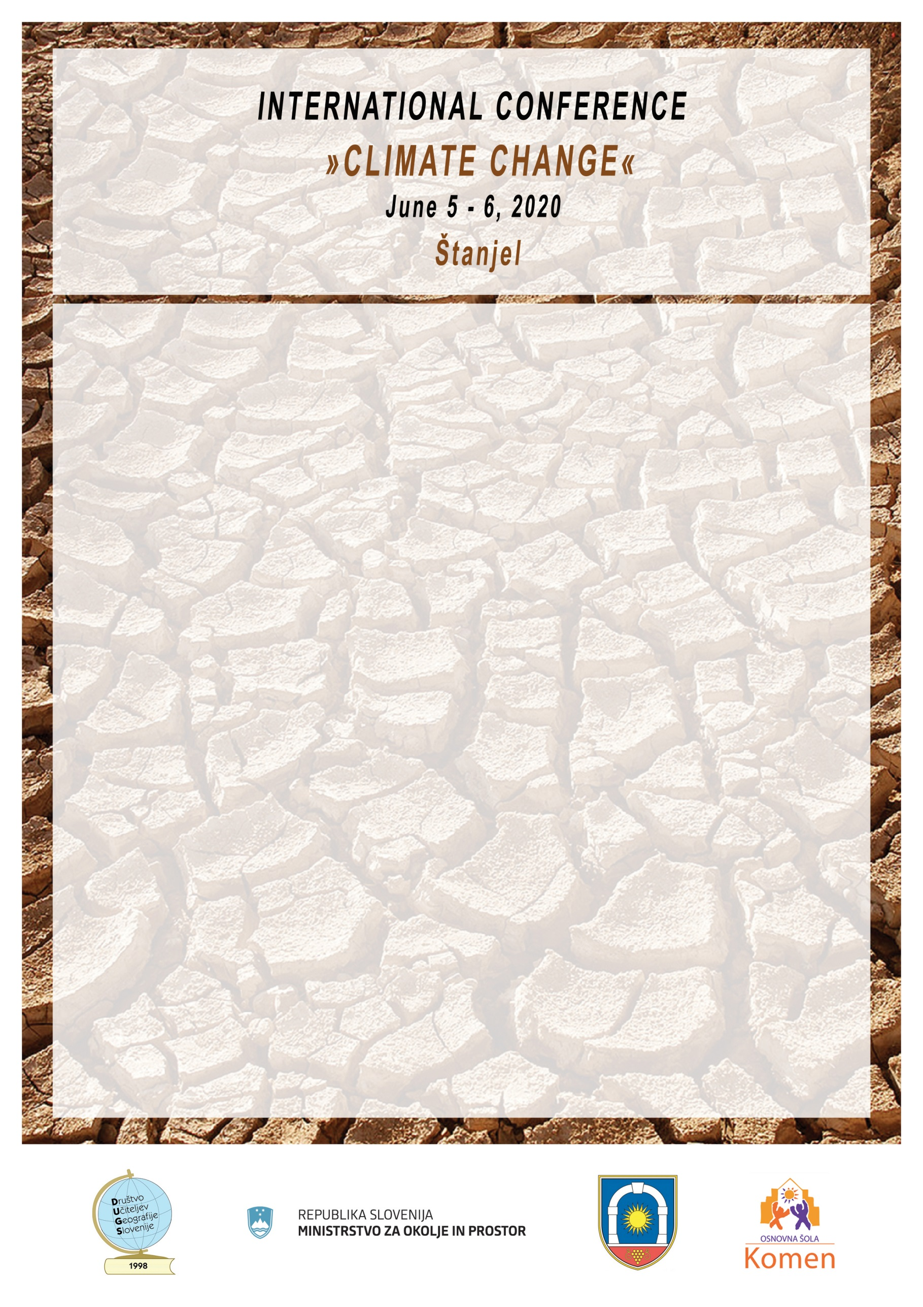

All authors should send us written Consent.

**Consent**

Name and surname:__________________________

Home address:______________________________

I agree with the publication of the Paper:_________________________________

in the Publication of papers from International Conference “Climate Change” and confirm, that I agree with the Guidelines, which are published at the Conference web site (http:/podnebne.splet.arnes.si), with the Contribution guidelines and Copyright agreements.

The Text of the Paper is proofread for grammatical and language errors.

Date: Signature:

Please send Your Paper to: [info@drustvo-dugs.si](mailto:info@drustvo-dugs.si)

Fullfilled Consent please sign, scan and send to: [info@drustvo-dugs.si](mailto:info@drustvo-dugs.si)

**Organising Committee**