TITLE
Name and Surname
School/Organisation
E-mail

ABSTRACT
Text
Key Words
(not more than three keywords)

1. INTRODUCTION
Introduction text…

2. TITLE
Text and quotations …
Climate change in Slovenia is still not… (Natek, 2007).

2.1 Subtitle
Text and quotations …

2.2 Subtitle
Text and quotations …

3. TITLE
3.1 Subtitle
Text and quotations … Picture and graph input and numbering and quatations.
 | 2008 | 2009 | 2010 | 2011 | 2012 | 2013 | 2014 | 2015 | 2016 | 2017 | 2018
SLOVENIJA | 1,7 | 1,5 | 1,8 | 1,6 | 1,3 | 0,9 | 1,1 | 0,4 | 0,3 | -0,1 | -0,4
Image 1. Natural increase per 1.000 Inhabitants. Source: https://www.stat.si/statweb (19. 11. 2019).

3.2 Subtitle
Images, graphics, tables and other enclousers should be be submitted digitally in the .png or .jpg format. It is required that the resolution is of at least 240 Pixels/cm (600 Pixels/inch). The images, graphics and tables should be inserted in the text. If the author of contribution is also the author of attachments his name under them is not obligatory.
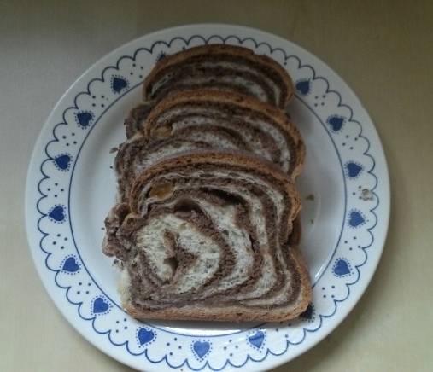
Image 2. Potica. Author: Mirsad Skorupan

3.3 Subtitle
Quotation. In the Text: (Natek, 2007)

3.4 Subtitle
Listing:
- Text;
- Text;
- Text.

4. RESULTS
Text and images …
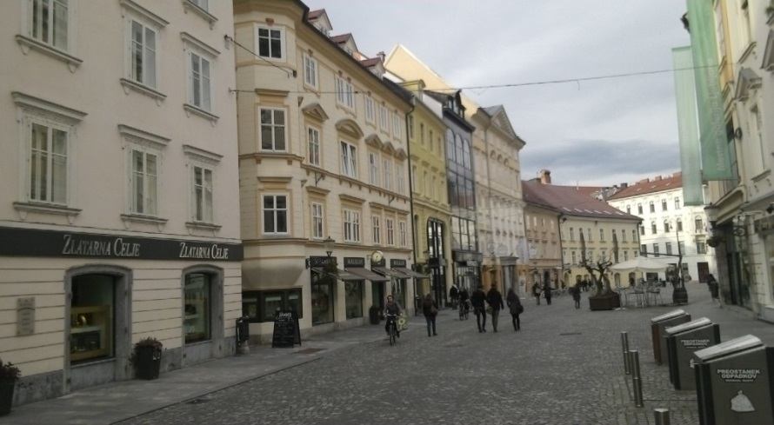
Image 3. Stari trg in Ljubljana. Author Mirsad Skorupan

5. CONCLUSION
Text

6. REFERENCES AND BIBLIOGRAPHY
- Natek, K. (2007). Periglacialne oblike na Pohorju. Dela, (27), 247–263. https://doi.org/10.4312/dela.27.247-263.
- Gams, I., 2004. Kras v Sloveniji v prostoru in času. Ljubljana, Založba ZRC, ZRC SAZU, 515 str.
- Smrekar, A., Kladnik, D., 2007. Zasebni vodnjaki in vrtine na območju Ljubljane. Ljubljana, Založba ZRC, 100 str.
- Karta zavarovanih območij v Sloveniji. ARSO. URL: http://www.arso.gov.si/narava/zavarovana%20obmo%C4%8Dja/karta/ (citirano 1. 3. 2011).

